SNOWFLAKE ACCESS CONTROL
There are two types of control that snowflake supports
- DAC
- RBAC
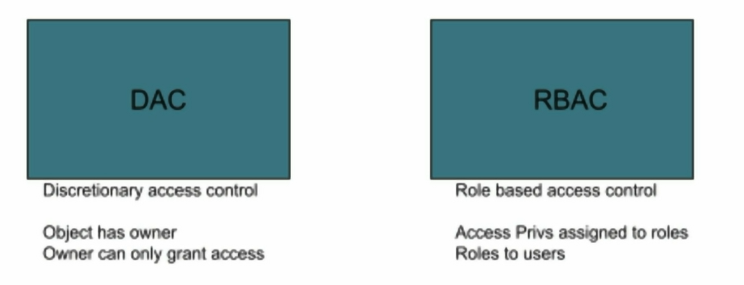
Key concepts:
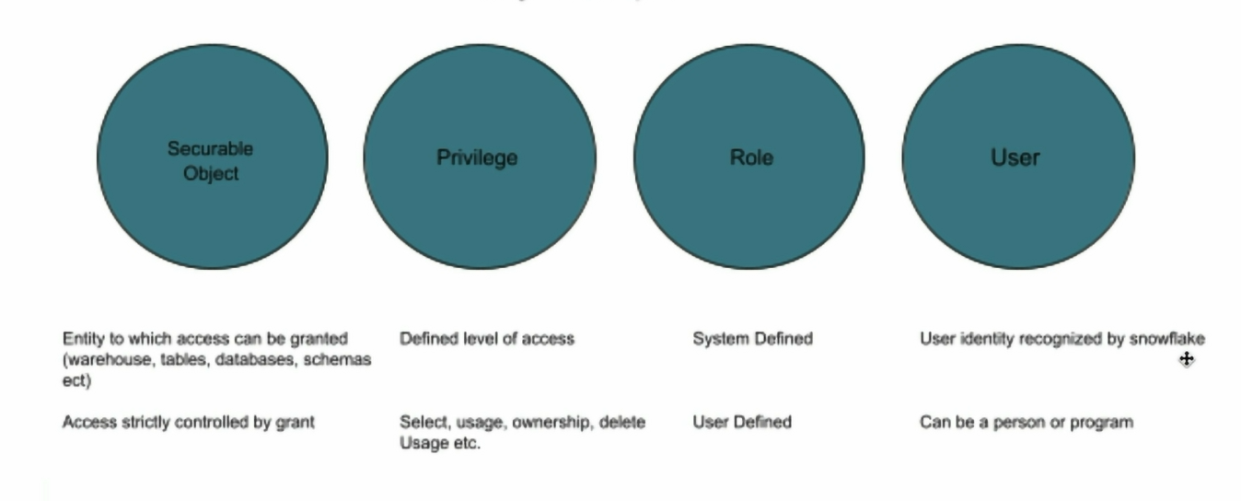
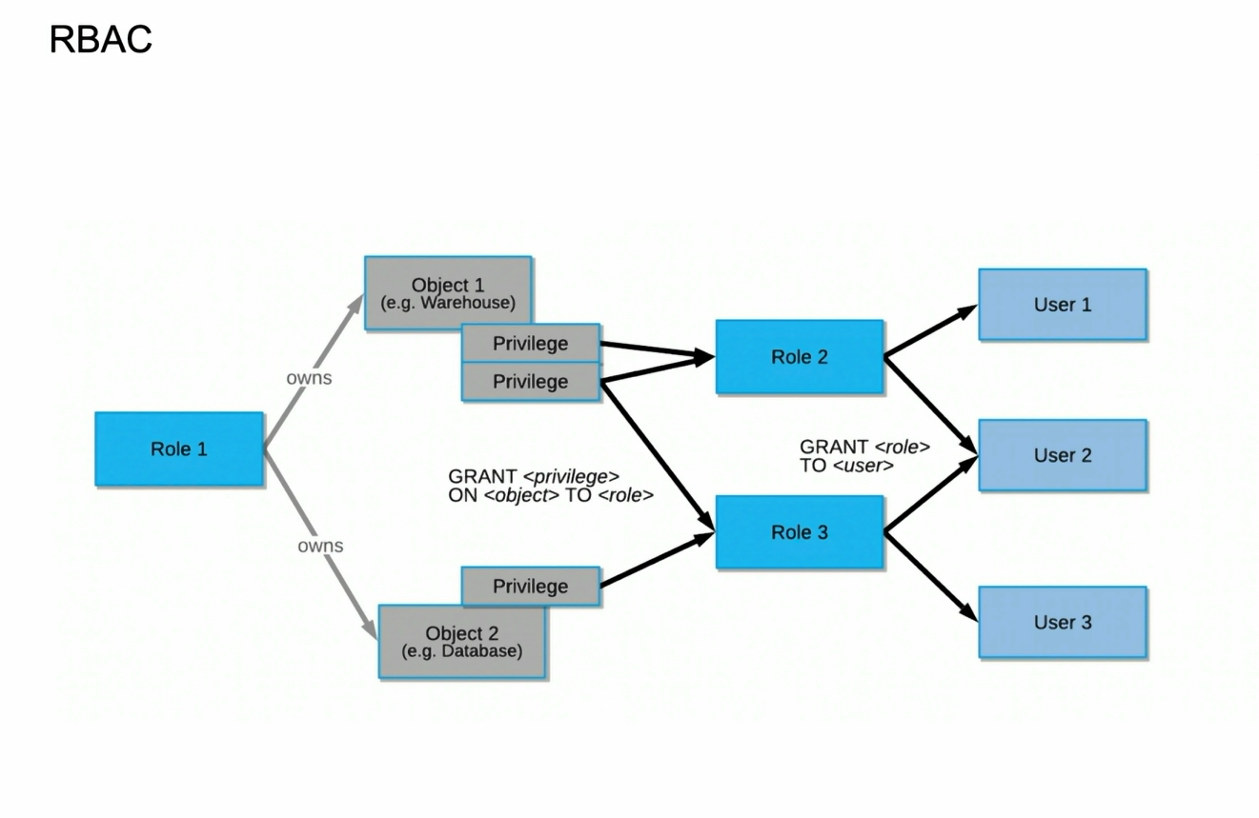
Securable objects
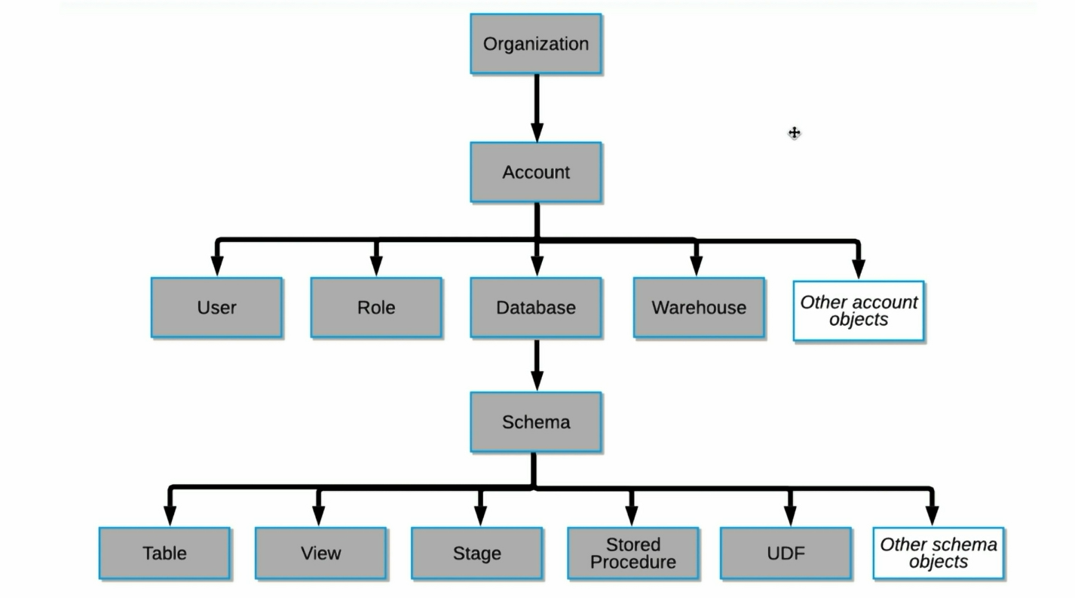

Under organization, you have account
To see in practical, change the role to orgadmin and go to admin—accounts
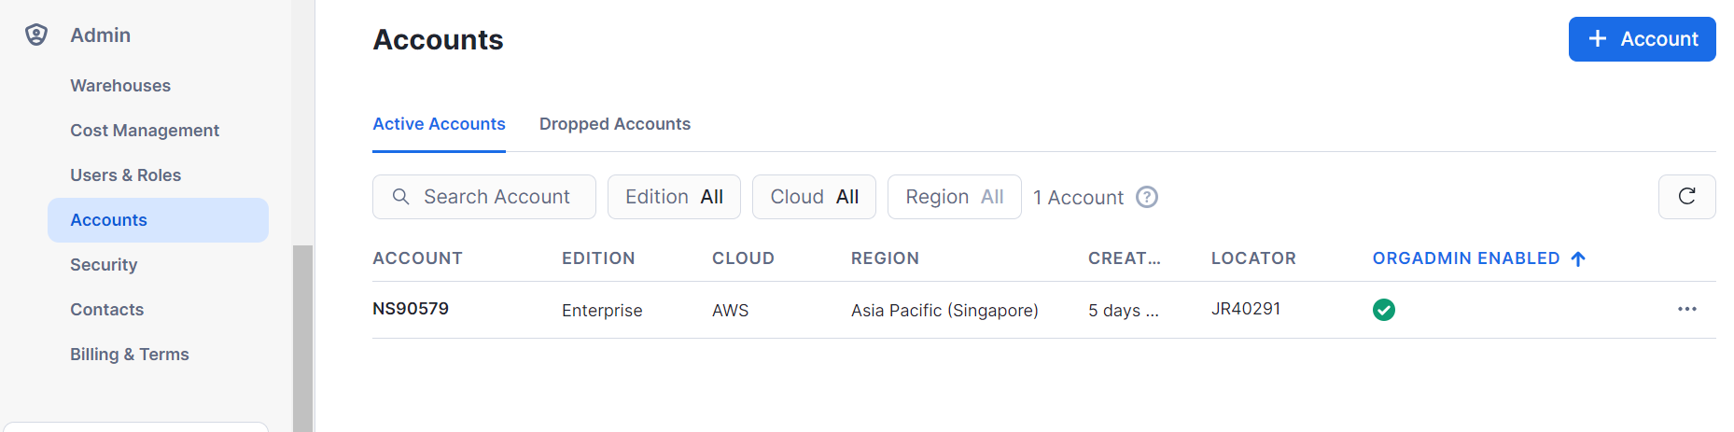
Now, change role to account admin and go to admin – users & roles
So under account, you can see users
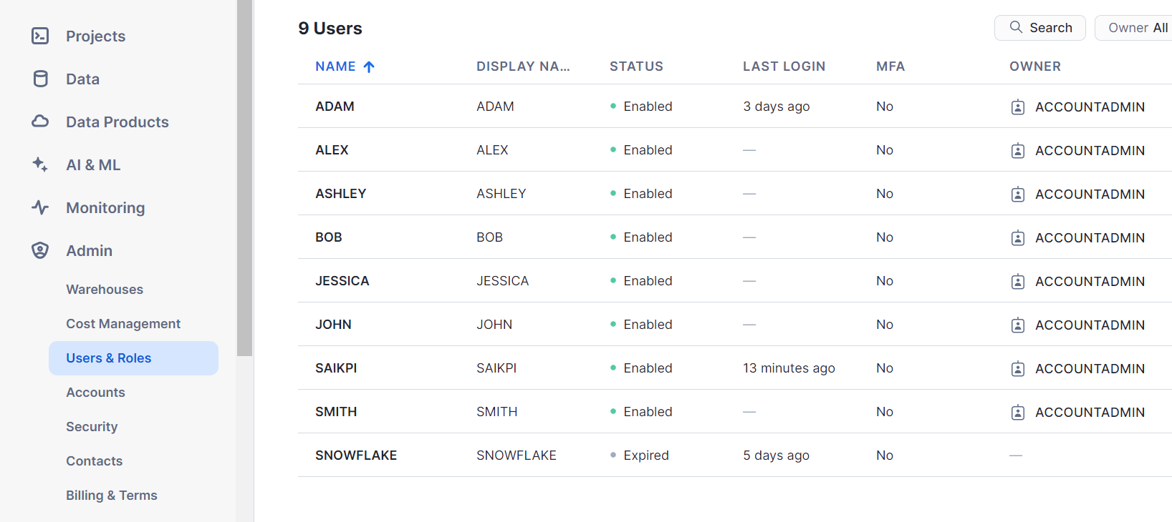
Under account, you can see roles
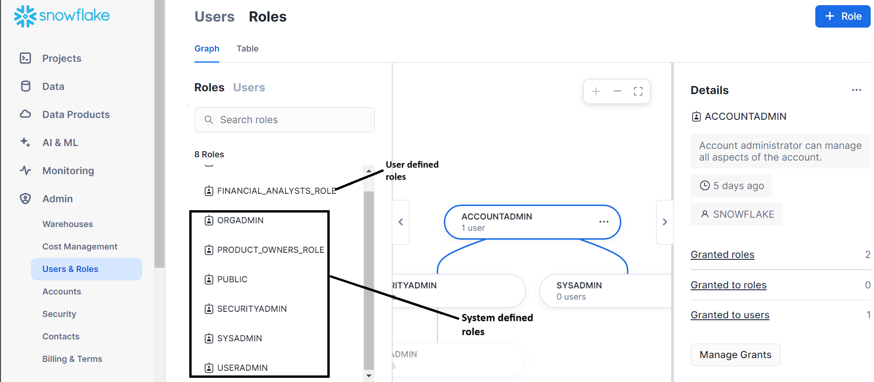
Under account, you can see databases
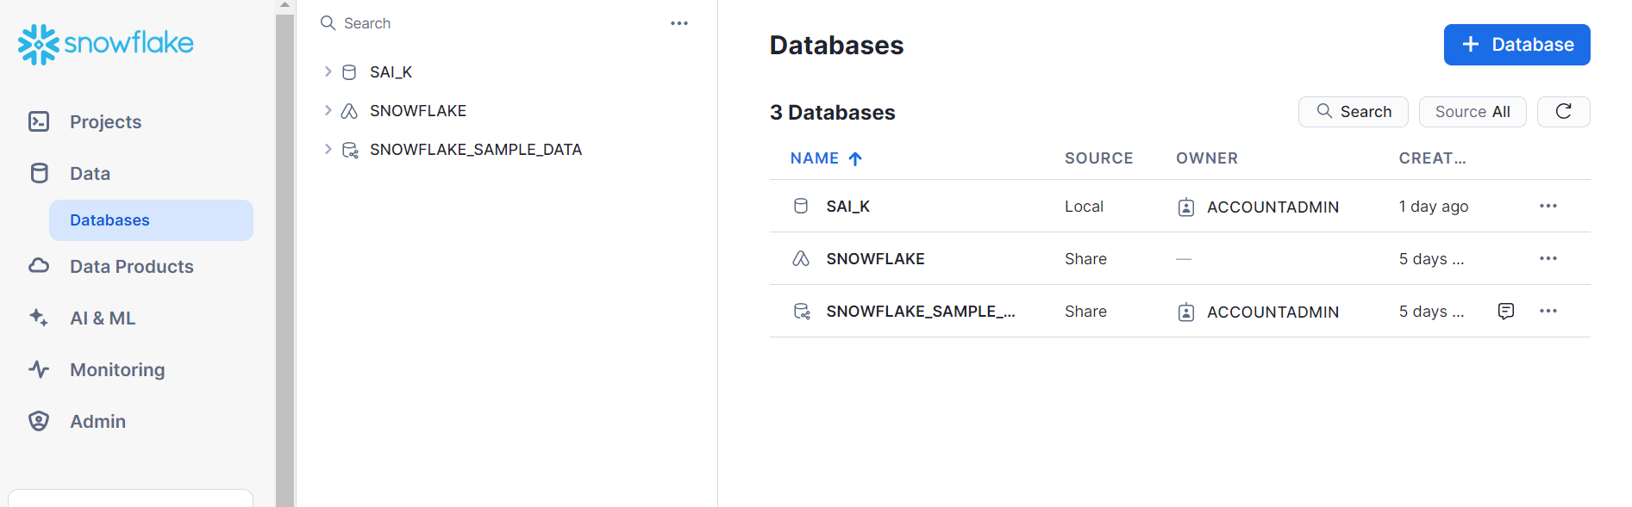
Under account, you can see warehouses
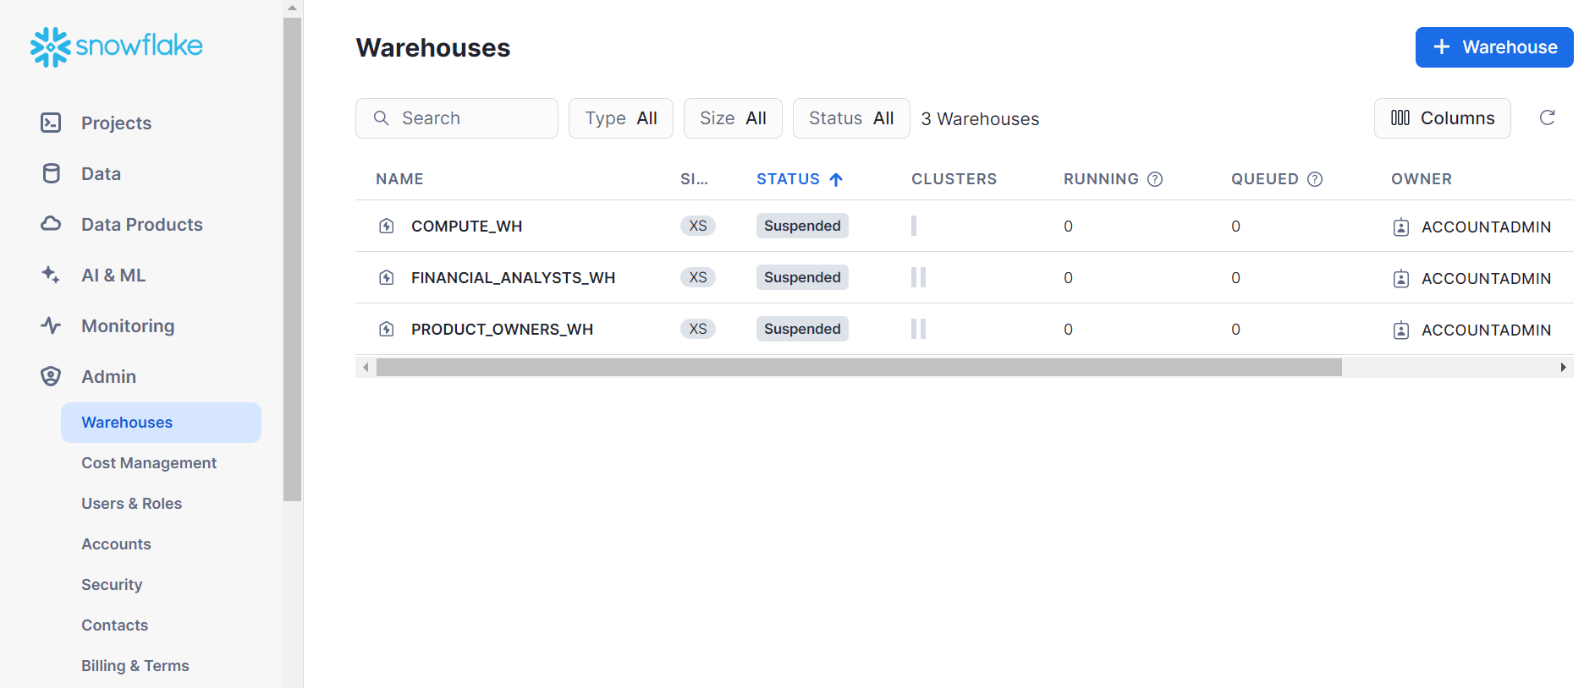
Under databases, you have schemas
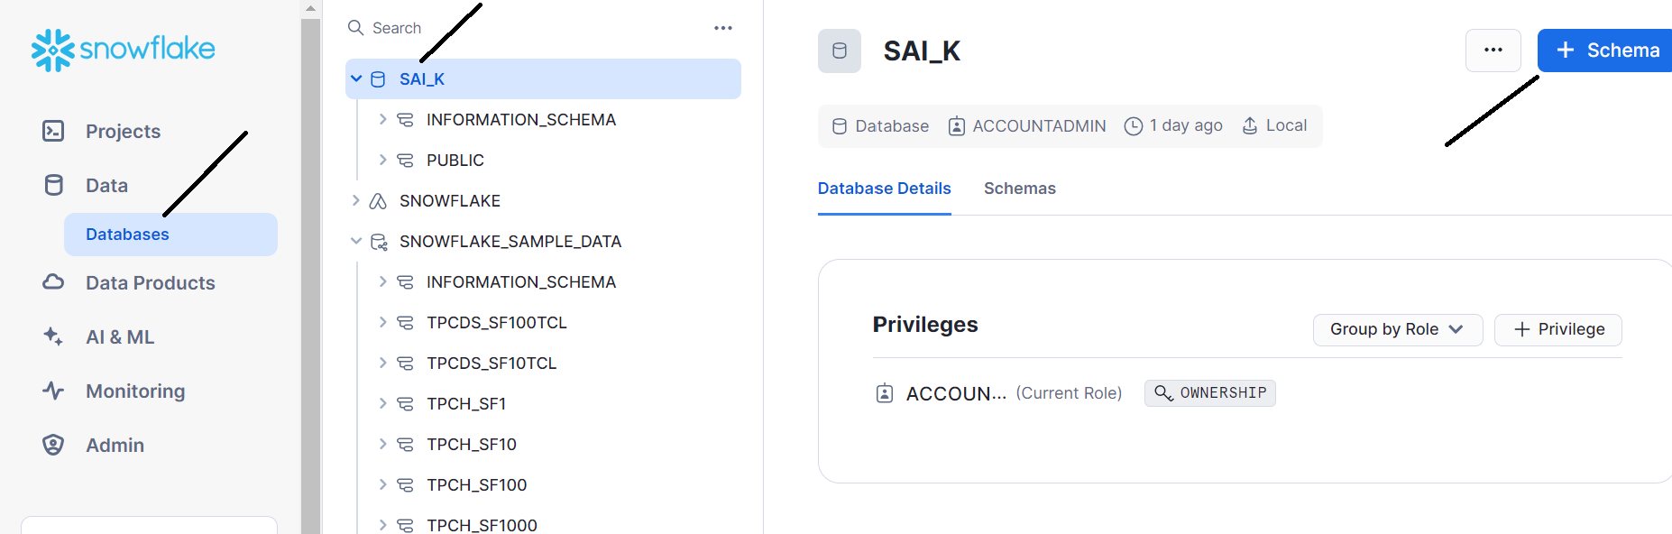
Now under schema, we have tables, views, stages, stored procedures, UDF’s etc. which we will see in detail in further step by step how to use it
Roles:
We have basically 6 system defined roles as shown
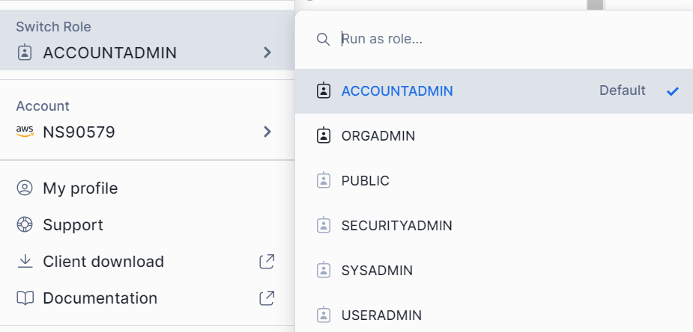
Organization of these roles is as shown
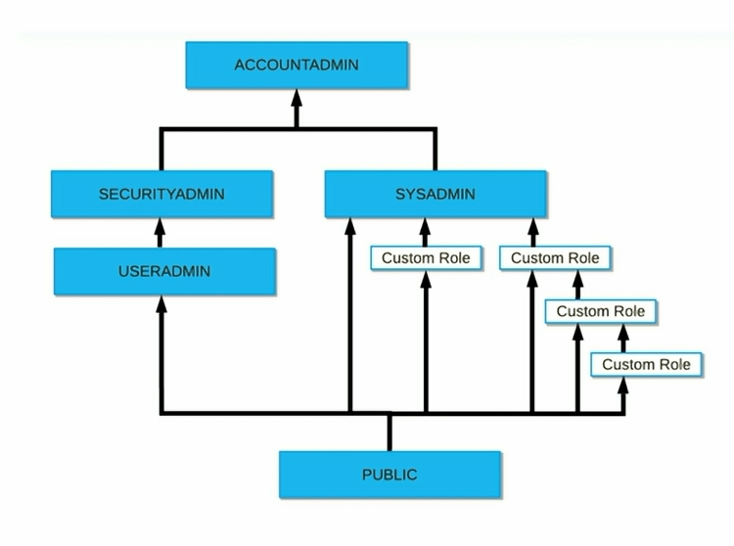
Account admin is top level role and it inherits all the access of security admin and sysadmin.
Security admin inherits all the access of useradmin.
By default to all the objects, public role is assigned
You can also create custom role hierarchy
Let’s see functions of system defined roles
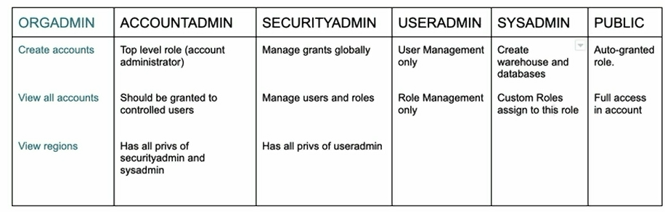

Practical applications of it will be explained in the upcoming posts

